AR Activity LEARNING MATERIALS
Instructions (1)
Please look at the following graph and table in conjunction with the group activity on the next page
Figure One: Trends in police recorded crime and CSEW, 1981 to year ending June 2013
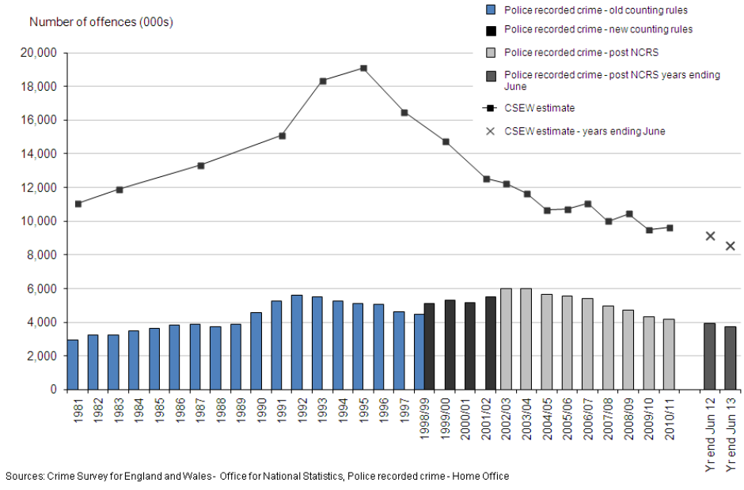
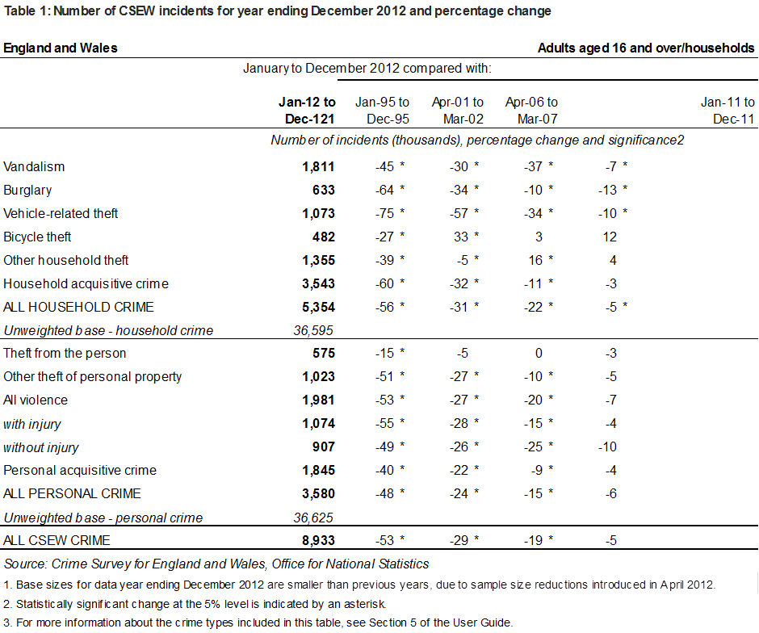
Group Activity (15 minutes)
Figure 1 details the officially recorded crime figures in the UK using two measures: Police Recorded Crime and the Crime Survey of England and Wales. Figure 1 shows that there has been a drop in overall recorded crime in the UK over the last two decades since the mid-1990s. Table 1 breaks down how different types of crime have dropped, illustrating that some forms of crime have reduced more than others (i.e. compare vehicle related crime to theft from person). Working in your group, please provide three reasons why you think crime as a whole has fallen in the UK. After you have done this please go to the next page.

Reason 1

Reason 2

Reason 3

Instructions (2)
Please look at the following graph in conjunction with the group activity below
Figure Two: The 2013 UK Peace Index
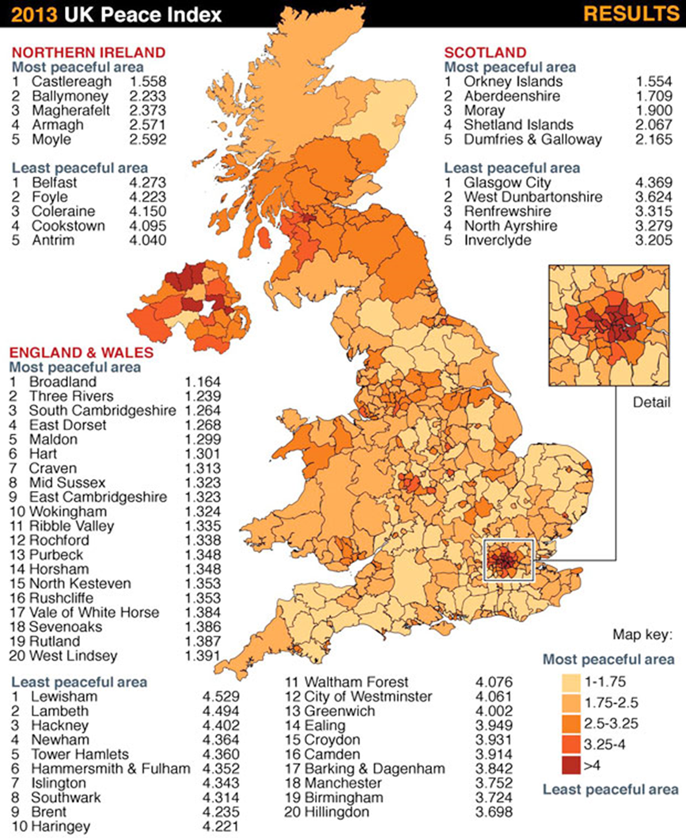
Source: Visions of Humanity (2013) Peace Index Report Available online at http://www.visionofhumanity.org/
Group Activity (15 minutes)
Table 1 visually displays the geographical distribution of crime across the UK, identifying the most and least peaceful areas (i.e. those with low and high crime rates). Within your group answer the following two interrelated questions and then proceed to the next page:
1) What does the map tell us about the distribution of crime across the UK between largely rural-small town and more heavily urbanized city areas? Can you give at least two reasons why more crime seems to happen in heavily urbanized city areas?
2) Revisit the three reasons for the crime drop which you recorded in following Instructions1 – do you wish to revise your reasons given the difference suggested by the Peace Index? If so, why, if not , why not?
Instructions (3)
Group Activity (30 minutes)
Look at the AR City map of crime rates across the city. In your group, provide answers to the following questions:
1) Is there a particular pattern to the distribution of different types of crime within the city? For example, are household burglaries more likely to happen in certain areas than others? Why do you think this might be the case? What consequences do you think this may have in terms of how crime could be responded to by the police, local business, homeowners, members of the public and the local city council?
2) Is there any pattern to the location of different types of crime and key factors such as urban geography (i.e. where housing estates and business districts are located) as well as layered AR data pertaining to housing type, unemployment rates, levels of welfare dependency and health-related factors. Can you explain why such patterns do/do not exist?

